No climate action without us

How to include disabled people in live event sustainability

Contents

Introduction
- Introducing the updated version of ‘No Climate Action Without Us’
- Research results

Themes
- Food and water
- Travel and transport
- Accessible facilities
- Communications and participation

Updated case studies

Summary

More resources

Introduction

By Suzanne Bull MBE

In 2023 - 2024 Attitude is Everything, Julie’s Bicycle and A Greener Future worked with disabled people and the live events industry to produce ‘No Climate Action Without Us’, a toolkit to enable the industry to implement climate change solutions that were also accessible to disabled people. We did this because there are more than one billion disabled people in the global population, they are more vulnerable to climate impacts than others, yet are often missing from climate conversations.
In February 2025, we publish the updated version of this toolkit with new ideas from the industry and disabled people, who have taken ideas to create more solutions. We’re thankful to everyone who took an active part in implementing the toolkit at their venues, festivals and events, and reported back to us.
The last version of the toolkit contained three festival case studies written by Dr Teresa Moore and these have been updated for this new version.
We continue to acknowledge that sometimes there might not be a solution available yet that is both accessible and environmentally friendly. Disabled people sometimes might require the use of single use items, cars, or additional equipment but they should never be blamed or shamed for this.

Research results

In 2023 we shared a public survey to understand some of the barriers and opportunities for disabled people engaging with sustainability initiatives at live events and festivals, followed by two roundtable discussions to explore some of the issues raised and practical responses for the sector. These roundtables included perspectives from event organisers, disabled artists and producers, and sustainability and access coordinators. It was on these findings that we created the first version of ‘No Climate Action Without Us.’

We received 107 survey responses from people who self-identified as disabled.
- 70% are audience members
- 30% are volunteers, artists, or events professionals

Many survey respondents struggled to identify environmental initiatives they had come across that were accessible.

We’ve drawn out the key themes that we’ve identified through this process to explore further through this toolkit.
● Food and water
● Travel and transport
● Accessible facilities
● Communications and participation

“We shouldn’t have to choose between what’s best for the planet and what’s best for us.”
- Anonymous survey response

What we found out…
- 66% of respondents said sustainability is a consideration.
- 50% feel excluded from participating in environmental efforts at live events and festivals.
- 33% feel that environmental solutions are not easy to navigate and do not meet their access needs*.
- 78% feel excluded and unable to participate in events and festivals that align with their climate values.
*Some solutions may be more accessible than others.
Food and water

Many events and festivals are embracing a move away from meat-heavy diets and plastic packaging. Refillable water points are now common within venues and at festival sites. But without careful planning, these can present additional issues for disabled people.

The challenges:
● Many water stations are not low enough for wheelchair users to access.
● Water points might be too far to access easily, and the ground beneath them can get too muddy for people with mobility impairments to navigate.
● The design of taps can be inaccessible for people with dexterity impairments.
● Plastic-free, organic food tends to be more expensive, but disabled audiences often have a lower budget.
● Dietary campaigns, such as meat and fish-free events, mean that people with serious food allergies, some chronic illnesses, and neurodivergent people with specific food requirements are restricted.
What can we do differently?
● Flooring that can be kept dry at and around water points.
● Make sure the tap design is easy to use.
● Ensure there are water points next to accessible camping facilities and viewing platforms.
● If you are committed to a specific dietary campaign, include a space for people to share their dietary needs or pre-order specific meals on the registration page or through other pre-event communications. Alternatively, allow people to bring in their own food.
● Emphasise a commitment to flexibility and inclusion.
● Engage with suppliers to see how water points can be tailored to meet different access requirements.
DF Concerts and Events have recycling and water points either on or around viewing platforms, which are only available to disabled customers. These water points are set lower down. A squeegee or brush is kept nearby to keep the area clean and dry.
All menus on TRNSMT’s festival site were in large print so that they didn't need to have different versions. This meant that all the menus met universal design standards, saving on printed paper.
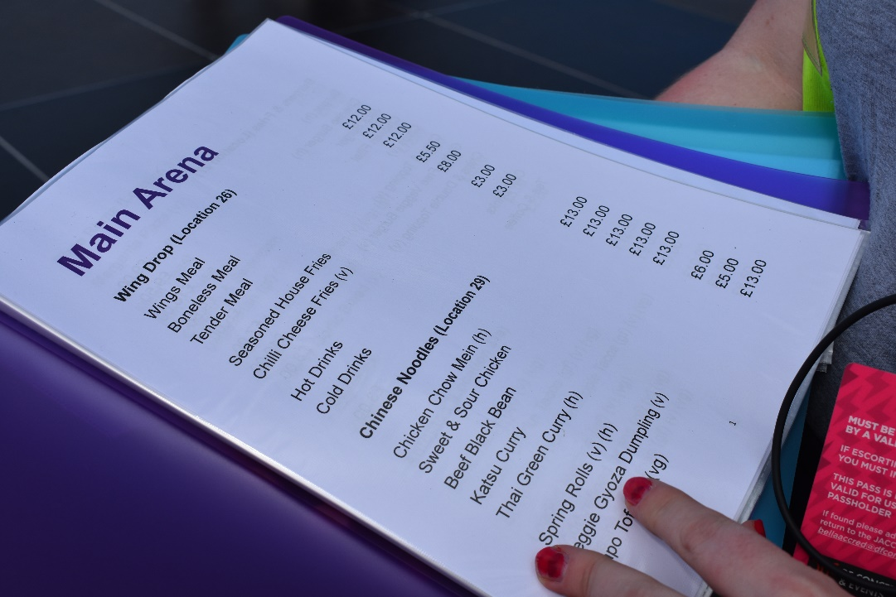
A page of large text on an A4 sheet in a folder that lists food and drink. It’s being held open by a hand.
Photo Credit: Alex Covell (from TRNSMT 2024).

Some of Attitude is Everything’s Charter venues recognise that organic foods and being plastic-free might not be accessible to disabled people because of financial or medical reasons. However, often the venue’s response is limited because of restrictions on what audience members can take into a venue or because the promoter can dictate venue policy as part of the artist rider. Some of Attitude is Everything’s Charter venues permit disabled customers to bring in their own food and drink if it’s a medical requirement. There is no question - it’s accepted as a reasonable adjustment. When this is permitted, bottle tops need to be removed and metal reusable bottles aren’t allowed as they can’t collapse down in an emergency situation, making them a potential trip hazard or weapon.
Permissions are decided on a case-by-case basis and the venue must run a risk assessment. Without consistent standards, it can be difficult to explain why venues have allowed this in one instance and not in others.
There are clear downsides to this policy. It means everyone has to buy drinks in single use plastic bottles with lids. The ‘lids off’ policy is hard for some disabled people as they may not have the strength in their hands to hold an open bottle of water for a length of time. This leads to spills, or time taken away from the show to refill bottles.
Some of Attitude is Everything’s Charter venues felt that assumptions were being made about the audiences. Not all audiences are the same, so there is a need for flexibility from promoters, and collaboration to find answers that are both sustainable and comfortable for their disabled customers.
Audience members themselves are now requesting different ways in which they can be sustainable. One venue had requests to bring a camping water bag instead of a reusable bottle. This is a welcome solution, which also requires some additional considerations. Does the bag come under the venue’s bag policy, or does it come under the bottles policy? If this is adopted as standard, is it acceptable to ask a disabled audience member to bring a water bag instead of a reusable bottle as this could be judged as an extra cost for disabled people?
Venues are exploring how they could work around all these questions to make their disabled audience members feel welcome and part of any sustainability solutions.

Travel and transport
Audience travel makes up a significant portion of the carbon footprint of live events and festivals. There are many fantastic initiatives to encourage a reduction in driving and increase the use of public transport and active travel, or shared coach and shuttle services. How can these initiatives be more accessible for audiences, artists, event workers and volunteers?

The challenges:
● Public transport may not be close enough to the venue or site.
● Disabled people might require additional equipment which means that they need to drive and park close to the site.
● Public transport and shared transport, like shuttle buses, can be inaccessible for people who require a wheelchair space or support with additional equipment.
● Neurodivergent people may also struggle with busy or unfamiliar public and shared transport options.
● Initiatives to make tickets cheaper for people using public transport inadvertently penalise disabled people who may be unable to use public or shared transport options.
● There are few suppliers for electric wheelchair accessible shuttles and coaches, or buggies to help people cover large distances on-site. They may not be available for hire in all parts of the country.

“There is a lack of accessible train stations so collectively we need to put the pressure on local councils and authorities to make those changes. Sometimes it feels like it is beyond our control but continuing to put that pressure on and continuing to share the voices of our audience where possible is so key.”
- Alex Covell, Live Events Access Manager, Attitude is Everything

“If there is an initiative to reduce driving to/parking at the event, it is often not accessible to me e.g. i would need to carry too much stuff with me and there is no assistance, or the bus stop is too far away.”

“Shuttle buses are rammed and standing room only. No hope getting on with crutches let alone a wheelchair, forcing you to always take a car.”

- Anonymous survey responses

What can we do differently?
● Work with local authorities and councils to implement accessible public transport routes which better serve your venues and events.
● Offer “quiet” shuttle options.
● Make sure that any transport initiatives do not make it more expensive for disabled attendees who need to drive.
● Discuss with suppliers how accessible transport options can be used as standard.
● Connect with other events and festivals locally to collectively drive demand for better electrified accessible buggies, shuttles, and coach services in your area.

Accessible facilities
Many of the festivals we spoke to have seen a huge increase in the number of disabled attendees feeling confident to attend their events. As the number and complexity of requirements increases, we have to find more nuanced sustainability solutions to ensure that disabled people are comfortable, safe, and able to fully participate.

The challenges:
● Many viewing platforms don’t have appropriate recycling bins, creating issues with litter, or require family, friends, Personal Assistants, Support Workers, Companions to leave for long periods of time.
● Litter and other items left on the ground present an obstacle for disabled people as this can be a trip hazard for visually impaired people and people with mobility impairments, and items can get stuck in the wheels of a chair.
● Waste and plastic free aims and recycling sorting systems do not adequately account for single use or disposable items which are a medical necessity for some disabled people.
● Huge increases in more complex requirements means that aids like hoists, mobility scooters, CPAP machines (which help clear the airways) and medical refrigerators require a lot more power.
● There is a lack of accessible compost toilets available in the UK.
● Cleanliness and the ability to wipe down and disinfect surfaces is important for people at high risk of infection, so compost toilets may not always be suitable.
What can we do differently?
● Make sure all viewing platforms and accessible camping areas have recycling facilities which are clearly signposted.
● When working on your plans to reduce your energy use, factor in constant power for medical equipment and mobility equipment at different times of day.
● Provide a range of toilets and Changing Places units so that people can be in sanitised environments if required.
● Share your plans for accessible provisions, e.g. compost toilets, to support market demand.

You might already have great green and accessible facilities. Automatic doors at venues are a good way of maintaining heating efficiency, so are a positive, sustainable solution. They are also an accessible solution for disabled people.

Shambala festival have planted a herb bed, filled with lavender, basil, and sage in their Quiet Area. Some festivals have sensory toys and backpacks which can be borrowed or hired. These can be filled with eco-friendly and reused items. These are cheap and an easy way to support neurodiverse audiences.

We learnt that many festivals had designed their own sustainable and accessible facilities because of the lack of appropriate suppliers.
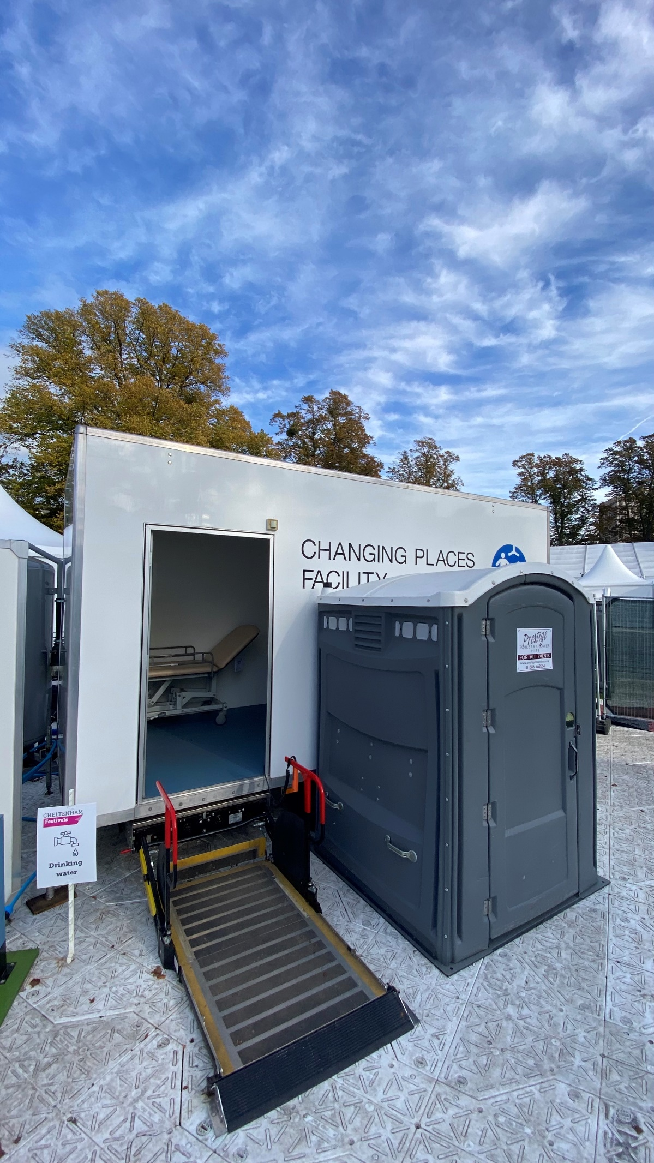
An accessible temporary toilet next to a mobile, accessible, mobile, larger ‘Changing Places’ toilet. There is a tail-lift into the larger, mobile toilet. There is sign that says drinking water with an image of a tap. There is an adjustable bed inside the larger, mobile toilet.
Photo Credit: Cheltenham Jazz Festival (2024).

Communications and participation
For many of our survey respondents, pre-event communication formed a key part of their decision whether or not to attend. Communication during the event also influenced the ability of people to engage in sustainability initiatives. Knowing what to expect, in clear language, and with well trained staff, contributes to the feeling of being welcome in a space. However, for many people, this is missing in sustainability information.

The challenges:
● Access and sustainability information are often on different parts of the website or in other resources. Sustainability information is often used in marketing so it’s idealistic and often uses jargon. In comparison, access information is practical. The two don’t reference one another.
● Information is shared too late, can be confusing or use too much jargon.
● Information is sometimes only provided on an app, which is not accessible to everyone.
● Sustainability staff are not trained in accessibility, and vice versa.
● Disabled people are not included in the planning of sustainability initiatives.

What can we do differently?
● Share clear, simple sustainability information alongside access information.
● Consider creating additional space on your website to “demystify” your access and sustainability initiatives.
● Provide as much information as possible at the point of booking so disabled attendees have the agency to make an informed decision about their ability to attend.
● Provide information in a variety of ways, at different points of the attendee experience online and in person.
● Use distance measurements instead of “walking time”, as this can be difficult to plan for disabled people.
● Engage with disabled people throughout the whole planning process. Venues can work with the disabled community in their neighbourhood and encourage their peers to do the same.

“Cheltenham Festivals engage with local specialist communities both in terms of accessibility and sustainability, who help on plans and do walk-rounds. For the next literature festival, they have planned a walk-through of accessibility and sustainability teams together to focus on this intersectionality. They are also partnering with Visit Gloucestershire and Visit Cheltenham, so they can provide information throughout their testing process. Their aim is to do sustainability with the accessibility community rather than to them!”
- Andrew Lansley, Innovation Manager, Cheltenham Festivals

This is a food map that also gives the carbon footprint. It’s also helpful for dietary requirements and it can be used if you get lost at a festival.

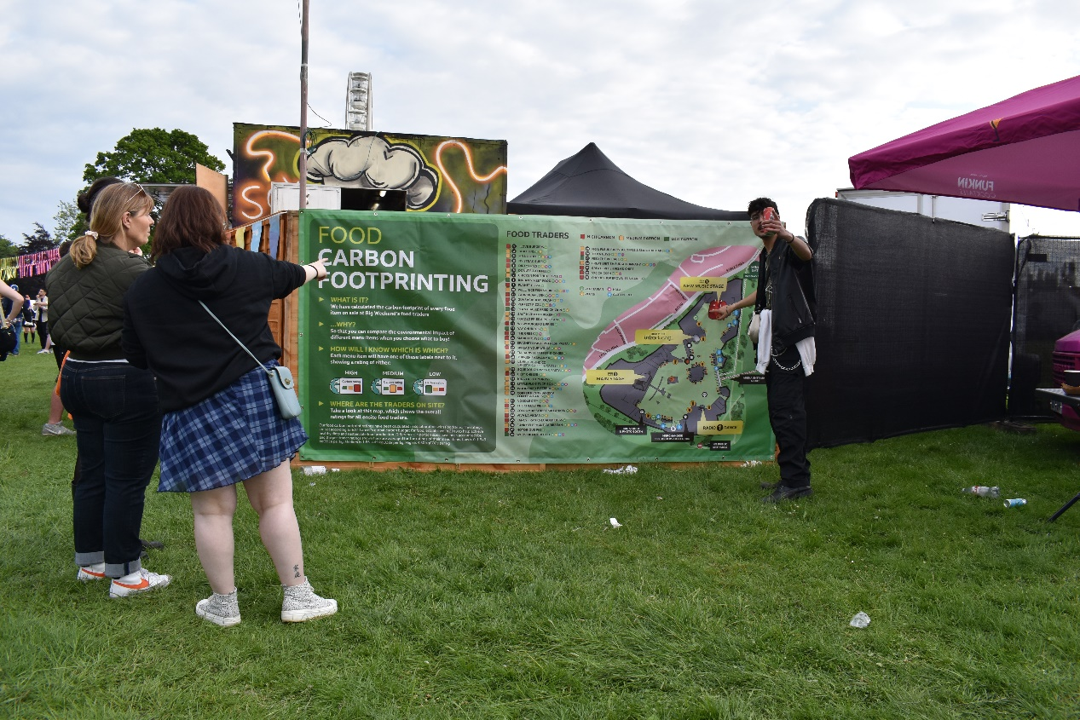
A large banner on a wooden fence that is a both a map and gives information about the festival site, including carbon footprinting.
Photo Credit: Alex Covell (festival unknown).

Case Studies
Prepared by Dr Teresa Moore

Case studies: Forwards Festival

About Forwards Festival
Where: Durham Downs, Clifton
Number of days: 2
Camping: No
Genre: Diverse, from punk to electronic. Also features talks, panels, workshops with a social and political emphasis.
Audience: 25-30,000 people daily, from late 20s to 50s.

Forwards Festival and the Environment
The festival has ambitious plans to reduce its carbon emissions through a joint approach between the attendees and the festival whilst supporting and collaborating with local businesses. Forwards Festival took the Vision 2025 pledge to reduce their entire environmental footprint by 50% by 2025, with the aim to be at net zero by 2030.

Accessibility
Ticket sales stabilised at 130 in 2024, approximately the same as the previous year.
The festival introduced an innovative technology partnership in 2023 aiming to provide people with visual impairments the chance to experience the festival via headsets, delivering streamed real-time content from the stage. This technology enables content to be tailored to each individual’s needs.
Other measures introduced include British Sign Language (BSL) to accompany acts, a diverse sensory space created with low stimulation and light for those with autism, anxiety and other health issues, high dependency toilets with water hoist or sling, and changing facilities on viewing platforms and elsewhere.
The topology of the site does, however, present some access issues. Whilst the main festival site is flat, getting to the main site is over hilly ground. The heavy tracking around the perimeter of the site aids accessibility, although there is no tracking used on the flat main site.

Being Green and Accessible - Particular Challenges
Toilets - The coded padlocks on the accessible toilets were found to be difficult to use and sometimes had to be cut open with bolt cutters, resulting in waste every year. The festival introduced a different type of padlock, Radar Padlocks which is a universal key access scheme to accessible toilets and reduced the number of padlocks purchased.
Water – As a direct result of this toolkit the festival re-examined the provision and accessibility of water onsite, and replaced stop taps with on/off lever arm tap handles for use in the accessible areas of the site.
Compost toilets have a bigger capacity than plastic bowl. A member of Team Love worked with a supplier to design a compost toilet unit suitable for wheelchair users. It provided a bigger space and incorporated handles, a frame and additional light.
Food and drink - to eliminate single use plastics the festival provides water in cans instead of bottles. However, they’ve found that the ring pulls create challenges for those who have dexterity impairments. They are also mindful that whilst sustainable packaging is important it needs to be easy to use and this isn’t always the case.
Audience Travel - the festival advocates green travel options including green coach travel to the festival site. However, at the moment, with few green coach companies there is a lack of supply which addresses accessibility issues.

Future plans
Forwards Festival have in their short history addressed many issues to do with both the environment and accessibility in innovative ways such as the design of an accessible compost toilet.
The festival advocates for the supply chain to provide a greater focus on human-centric design and improvements to facilities for disabled people.
They recognise however that there is still work to do and identify a number of areas for focus: -
- An appraisal of waste management measures to focus on accessibility such as issues with bin height, signage, shape and colour (to account for colour blindness) of waste separation schemes.
- The height and ease of use of water points.
- Whilst already providing an access information pack in a digital and downloadable printable pdf, they feel that they should do more to talk about what they are doing to make their festival more accessible in their programme of talks and workshops.
- The festival recognises that more people bring their own food than previously, and that issues around food allergies are becoming of greater concern. Providing information about onsite food menus before the festival is increasingly important.

Case Studies: Green Man Festival

About Green Man Festival
Where: Bannau Brycheiniog
Number of days: 4
Camping: Yes
Genre: a wide-ranging programme including music, literature, comedy, cabaret and cinema
Audience: 25,000 attendees, a diverse audience of young families, teenagers and older people
The Green Man team also runs an event called Settlement for the few days before the festival starts which allows a smaller number to, well, settle in and have time to explore and enjoy the surrounding countryside before the main event.
Green Man Festival has a loyal audience with around 80% returning annually. The 2025 edition of the festival sold out in an hour of the tickets being launched.

Green Man Festival’s Environmental Ambitions

As its name suggests, being green is at the heart of the festival and influences everything they do. Initiatives to encourage more sustainable travel options, reusable cups, the use of HVO (Hydrotreated Vegetable Oil) and solar power, and compost toilets, to name just a few have been adopted to reduce the festival’s environmental impact. They are a founding supporter of Vision 2025 and have pledged to reduce the festival’s environmental impact by 50% by 2025. To further support their green goal, they have undertaken the A Greener Future certification in 2023 and 2024. The results will provide an independent assessment of how they are doing and those areas where more could be done to reduce the festival’s environmental impact.

Providing Accessibility for All

Not only is the festival focused on being as green as possible, it also works hard to make it as accessible as possible so that everyone can enjoy the festival. They are proud of their Gold Charter accreditation from Attitude is Everything. The numbers attending the festival and using the facilities is gradually increasing each year. In 2023 they sold over 150 companion tickets.
As part of their mission to make the festival as accessible as possible the organisers have introduced many facilities. There is a dedicated accessible campsite which is located in the middle of the festival site to make access to the main stages and transport points as easy as possible. The facilities include accessible showers and toilets, viewing platforms, BSL, trackway and mobility scooters. There are ramps onto stages, not just for customers, but for staff, crew and artists. They have a support team many of whom are disabled people themselves, which includes their onsite Accessibility Manager.

Being Green and Accessible

Being green and at the same time providing accessibility is not without its challenges and at times the measures to provide access can conflict with their ambition to be as green as possible. Festival managers, along with the procurement and operations teams, were supplied with the No Climate Action Without Us toolkit to ensure that everyone understood what the festival was trying to achieve in this area.

Accessibility - Supply Chain and Transport Emissions

The Green Man team identified issues to do with the lack of key infrastructure provision across the supply chain. For example, there are a limited number of suppliers of these accessible toilets, and they are not local. To provide accessible toilets the festival must use suppliers from further afield, increasing transport miles for delivery and removal of toilets. Further, each accessible toilet is bigger than a standard toilet. As a result, fewer toilets can be delivered in one load creating more delivery and removal trips. Additionally, there are few accessible compost toilets available for hire. We know these are much better for the environment than chemical toilets.

Accessibility and the Provision of Water

To conserve water and limit waste the festival installs stop taps on tap tables. To make water more accessible the taps are set for 15 seconds. A Greener Future advises that this is longer than is normal which means that more water is being used. However, it’s difficult for the festival to shorten the flow time further as they recognise that where a festival goer has difficulty pushing the stop taps they need a longer time for the water flow to stay on. The team introduced an improvised solution which worked well. For all stop taps except those for disabled people, cable ties were used reducing flowtime, but retaining stop tap function.

Conclusions

Making Green Man Festival as green as possible and at the same time as accessible as possible presents a number of specific challenges for the team, and for other festivals with the same ambitions.
The No Climate Action Without Us toolkit increases leverage with suppliers to improve facility design for disabled access. More advice on influencing suppliers and advocating for changes to design and provision of improved facilities would help.
Case Studies: Shambala

About Shambala Festival
Where: Northamptonshire
Number of days: 4
Camping: Yes
Genre: Rock, pop, folk and world music
Audience: 18,000 - 20,000 Family
Requests for access facilities 2023: 280 people (2022, 156: 80% increase)
46 crew applied for Personal Assistant / Companion tickets 2023 (2022, 16: 300% increase)

Shambala Festival’s Environmental Ambitions

Shambala Festival has sustainability embedded into every aspect of the festival and in 2022 they achieved the highest award “Outstanding” from A Greener Future certification.

Providing Accessibility for All
The festival is focused on being inclusive and has a dedicated member of staff who works year-round to organise the accessibility services. Onsite, the Access Team is a crew of 16 who are all either disabled or with extensive lived experience of disability, and who work in the sector.
There is a growing interest in attending the festival from disabled people and a year-on-year increase in accessibility applications. In 2024 there was a 17% increase in demand for accessibility services including radar keys for toilets, wristbands for viewing platforms and buggy lifts for those who were camping.

Being Green and Accessible - Particular Challenges and Solutions

Travel - One of the biggest challenges in providing accessibility that is also green has been around the eco traveller packages sold by the festival to encourage green travel options. The eco traveller package is a coach/train ticket combined with a reduced-price festival ticket. Unfortunately, whilst the coaches do have wheelchair lifts, the take up for the service by disabled people has not been what was hoped for. It is thought that travelling by coach increases the complexity of the journey for disabled people, which is why it is not popular. The most favoured means of transport is still by car/campervan. The festival imposes a carbon balancing levy on car travel as well as charging for car passes/campervan tickets. This increases the price for those disabled people who have to travel by car and camper van.
The organisers have looked at the problem and have introduced two free vehicle passes for any applicant who provides the same documentation that is required for a PA (Personal Assistant) / Companion ticket. The drawback is that the free campervan spaces are all in the accessible camping area, which means that people who wish to stay in the family field or elsewhere, have to pay for their campervan ticket. The festival finds workarounds for this on a case-by-case basis.

Waste Management - The festival has a recycling exchange where the audience take their rubbish. This was not accessible for all as it was away from the accessible campsite. Instead, the recycling team visit the accessible camping area at an allotted time and the access team also shuttle recycling for people although disabled people camped elsewhere still have to move and sort their own recycling.

Water and Toilets –
The research conducted for this toolkit identified general issues around accessible water points and taps across many festivals. At Shambala, the team plans to focus on improving accessibility in 2025.
The festival had 15 wheelchair accessible compost toilets and 10 wheelchair accessible chemical toilets. The suppliers of the compost toilets are not local which does increase the transport miles to get them on site.
Food and food traders - Shambala emails all food traders in advance to request that they consider disabled customers when planning their stall. The access team walks around the festival to check that accessibility measures are in place such as lower counters and visible menus. They speak to food traders as well as crew about any potential issues. The festival is meat and cow milk free which means that there is more food containing nuts and seeds; this has created some problems for those with allergies who often need to bring their own food and mini fridges to keep it fresh.
Food traders are asked to provide locally sourced and organic food, which is often more expensive and can directly impact disabled people. Feedback from those affected suggested that providing more information about the types of food available in advance of the festival would be helpful.
Power Usage - Although all power on site is renewable, the use of mini fridges for food storage increases power requirements. CPAP (assisted breathing) machines at night are becoming more common and this too means a heavier use of power.
Communications - The festival website presents its many sustainability and accessibility initiatives, but the sustainability information is very wordy and not particularly accessible.

Conclusions

Shambala Festival’s approach is to solve problems and does its best to recognise and provide solutions where access issues arise. A full review of the festival’s sustainability policies in conjunction with their impact on accessibility is ongoing.

What can you do?

● Test the suggestions throughout this toolkit for how we can work differently.
● Connect your sustainability team with your access team and work through solutions together.
● Engage with disabled people throughout every step of your planning process. Listen to disabled people and work with them to find solutions.
● Connect with other local events, venues and festivals to share ideas and resources, potentially creating a local access equipment store that can be shared across festivals and events.
● Connect with membership organisations and as a collective, find ways to increase the supply of sustainable, accessible equipment and facilities.
● Keep informed about the initiatives and resources that Julie’s Bicycle, Attitude is Everything and A Greener Future have – someone, somewhere will have the solution!

Pledges for the sector:

- To come together with disabled people, industry colleagues and suppliers to design, create and then increase the supply of accessible, sustainable products and facilities.
- To continue to use the toolkit and implement its solutions.
- Use Attitude is Everything’s Live Events Charter network to feedback new ideas and solutions so that your industry peers can benefit.

Additional resources
Accessibility resources
● Attitude is Everything - resources covering access for artists, audiences, and professionals
● We Shall Not Be Removed - The Seven Principles for an Inclusive Recovery

Sustainability resources
● Julie’s Bicycle Resource Hub
● A Greener Future Resources
● Vision 2025

Acknowledgements

This toolkit was prepared by Julie’s Bicycle, Attitude is Everything, and A Greener Future. Funding from Arts Council England has enabled us to run this programme.
Thank you to everyone who contributed solutions and ideas to this toolkit, as well as Shambala, Forwards Festival and Green Man for updating their case studies. All contributions have been invaluable in shaping the toolkit.

Attitude is Everything

Attitude is Everything connect disabled people with music and live event industries to improve access together.
Our vision is to see music and live event industries valuing disabled people as audience members, performers, professionals and volunteers. Our work won’t stop until this becomes the norm.
Through our work:
- Disabled people lead the change.
- Industry professionals learn from real-life experience and expertise.
- Barriers are identified and removed.
- Best practice is celebrated and rewarded.

Julie’s Bicycle

Julie’s Bicycle is a pioneering not-for-profit, mobilising the arts and culture to take action on the climate, nature and justice crisis.
Founded by the music industry in 2007 and now working across the arts and culture, JB has partnered with over 2000 organisations in the UK and internationally. Combining cultural and environmental expertise, Julie’s Bicycle focuses on high-impact programmes and policy change to meet the climate crisis head-on.

A Greener Future

AGF is a not-for-profit company helping organisations, events, festivals and venues around the world to be more sustainable and reduce environmental impacts. Pioneers in event sustainability since 2005, and founders of the world’s first green event and festival certification, AGF provide training, expertise, support, carbon footprint and Net Zero strategy, and facilitate exchange through events and networking.

Charity Numbers
Attitude is Everything – 1121975
Julie’s Bicycle - 1153441

